Bingo! Certainty!
by Dr. John N. Hait
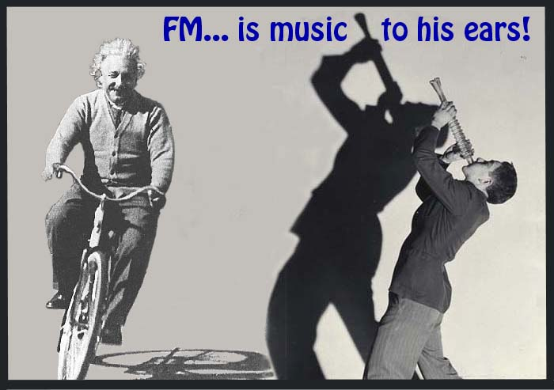
The key to discovering the ‘holy grail’ of science, reconciling Quantum Mechanics with Relativity in order to produce a truly unified explanation of how everything really works, lies not in finding a string of complex and impossible-to-understand, multidimensional-supplements to these conflicting branches of physics, but in a simple correction to the foundation of Quantum Mechanics itself.
The evidence in support of this fundamental change is all around us… even on the radio! Electromagnetic energy of all wavelengths has been shown to be precisely quantized into wave-packets having exact amounts of energy, multiples of Planck’s constant. Therefore, it is not the amount of energy that Quantum Mechanical theory, based on the Uncertainty Principle, claims is ‘uncertain’… preventing unification with Relativity by being unreliable, unmeasurable and un-understandable. But it is the arrival timing of each quantum particle that is supposed to be ‘uncertain’.
Otherwise, the signal isn’t really ‘uncertain’ at all, but would be precisely and reliably ‘certain’. That is, accurately timed, dependable, consistent, reproducible, measurable, describable with non-statistical mathematics, and therefore… understandable!
The underlying problem is: the photonic particle is imagined to be much shorter, and thus is assumed to interact with other things much quicker, than the full cycle time (period) of each wavelength. Accordingly, this would be the case, regardless of whether such interactions constitute ‘observations’ or ‘measurements’ or not, and regardless of whether the phenomenon is below the Quantum Limit or not. For, the Uncertainty Principle holds that whatever happens below the limit must accumulate to produce the observed phenomenon.
Thus, the arrival times of the individual photonic particles within successive cycles must vary randomly… that is, be ‘uncertain’. Only after the accumulation of many such particles, according to their assigned probabilities, (a non-random activity often ignored,) does the familiar sine wave function supposedly become manifest.
However, this primal view is contrary to easily-observed facts using 21st century tools. Because there is no mechanism in free space for storing energy from successive cycles, which would affect the start time of each cycle, [forcing the phenomenon to become analog rather than quantized,] no cycle can begin or interact with anything else… until its particle of energy shows up.
Because the start time of each cycle determines its phase… if the Uncertainty Principle really is fundamental to nature, then every electromagnetic signal under all circumstances must always exhibit random and thus ‘uncertain’ phase. Otherwise, there would be nothing left to be ‘uncertain’ about!
Therefore, the demonstrated existence of any electromagnetic signal having a consistent phase would constitute a direct violation of the Uncertainty Principle, proving that Uncertainty is not a fundamental quality of everything.
Laser beams can be easily produced having a consistent phase even over considerable distances… it’s called ‘coherence length’. If the Uncertainty Principle is truly a fundamental quality of nature, then lasers won’t work! Including your laser-pointer.
If Uncertainty is true, then every FM radio would contain an un-removable random-phase-modulation… a white noise. We could call it “Heisenberg Noise”, rendering all beautiful FM music quite unpleasant to listen to… because FM radio detectors automatically respond to both frequency and phase changes.
The fundamental mechanism of physics, the basis of how everything is constructed is not random. It is precise, reliable, consistent, and can be described with non-statistical mathematics. It is certain! And most importantly, it always gets it right, and it never forgets how to do it!
However it is also complex, convoluted… sequential. It is all of those things that random-based things are not. So logically, it must be pseudorandom. And it is precisely described by the easy-to-understand Resonant Field Theory of Everything. Explained in a new book available at www.ResonantFieldsInc.com.
Bingo! Corrected Quantum Mechanics and Relativity can now be easily unified and understood. Consequently, all forms of energy, from zero-point energy, to nuclear fusion, and even the practical application of alternative energy, can now be more easily understood and examined. Logically, this advanced insight is expected to generate multiple clean and Earth-compatible technologies that can now implement these various phenomena in novel ways.
The unified Resonant Field Theory is opening many doors of opportunity with ‘certainty,’ that have been stuck in the mud of ‘uncertainty’ all these years. Now you can insert ‘certainty’ into your research also.
For a complete course in advanced resonant fields, see about the coming Resonant Fields International Conference at www.ResonantFieldsInc.com.

©2006Hait

